Software Development Unit 3, 3.2

Anna Legaspi

# I can assess what permissions are needed for different users and content

Most collaborative software/website has its own privacy settings. Nowadays, almost everyone’s information is available online. As useful as this may be, it’s still important to ensure that only people who are privy to the data uploaded can access the information. I’ve set a few examples below of a few different software that supports collaborative technology and how to manage access by others.

It is also important to note how a user can create these collaborative accounts. Most accounts when created online, need basic information including their full name and email address; sometimes, even an address and telephone number. Most of the time, before an account can be used, a verification email is sent to the user. This enables the collaborative software/website so confirm that the correct email address is registered to the new account. At the same time, this can be used to reset passwords and even setup 2FA (Two-factor-authentication) for a more robust security. This prevents malicious scammers from accessing people’s accounts.

## Windows

It’s common to have a shared desktop/laptop and to have multiple profiles in on device. A user may want to share their file(s) and grant permission to another user. This can be done by right-clicking the relevant file and going to the Security tab and selecting ‘Edit’. Here, access can be changed, depending on the profile user.

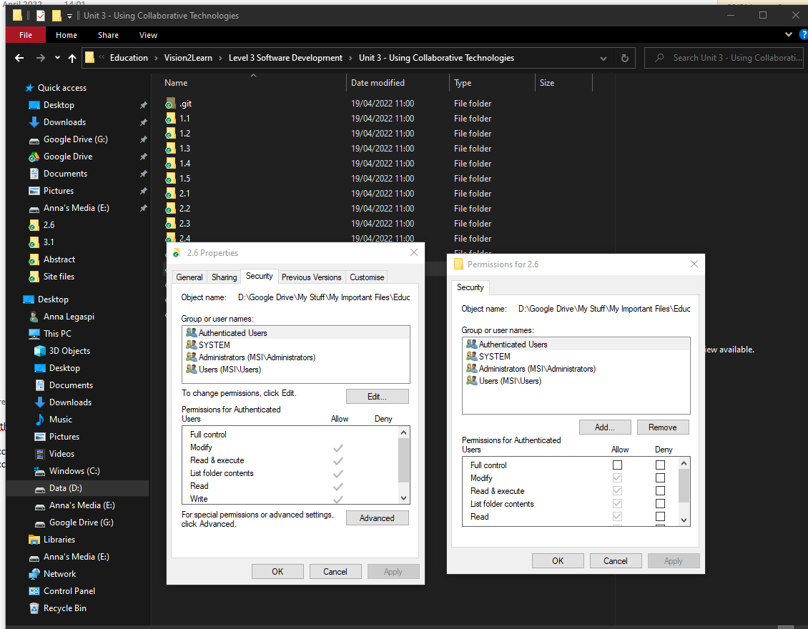

## Github

Github is a collaborative website where people can upload coding and files. Users can create their own account and manage other collaborator’s access to their files.

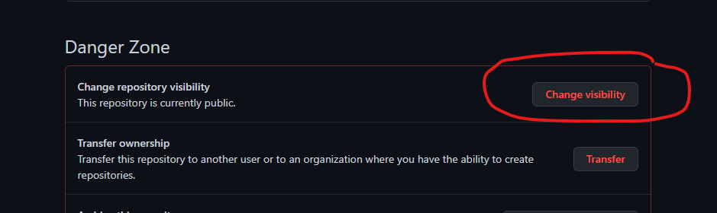

Above: User’s can change the repositories visibility to either Public or Private.

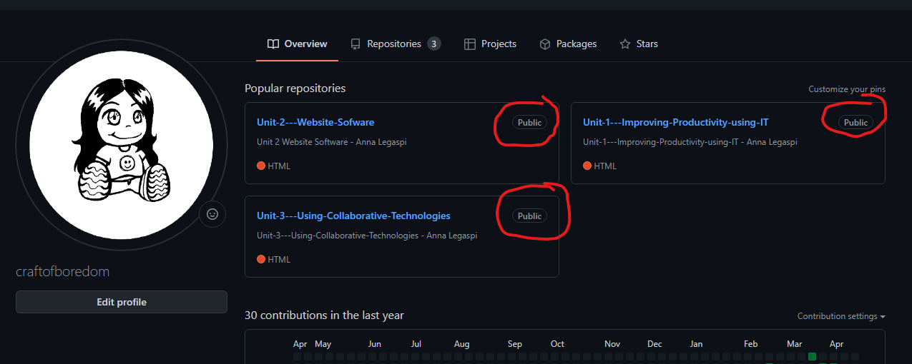

Above: If it’s set to Public, anyone with a link will be able to access the files. If set to Private, only the user will be able to access this.

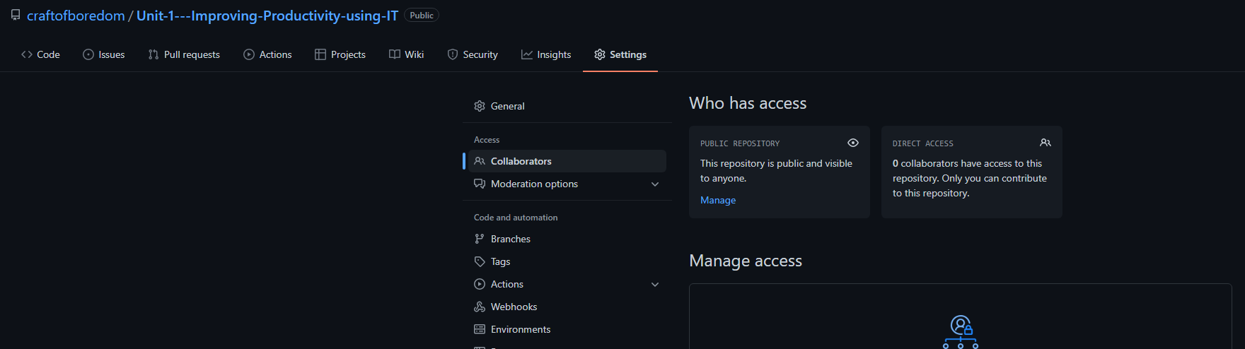

The user can also add specific collaborators to a list. In the example above, I have NIL collaborators.

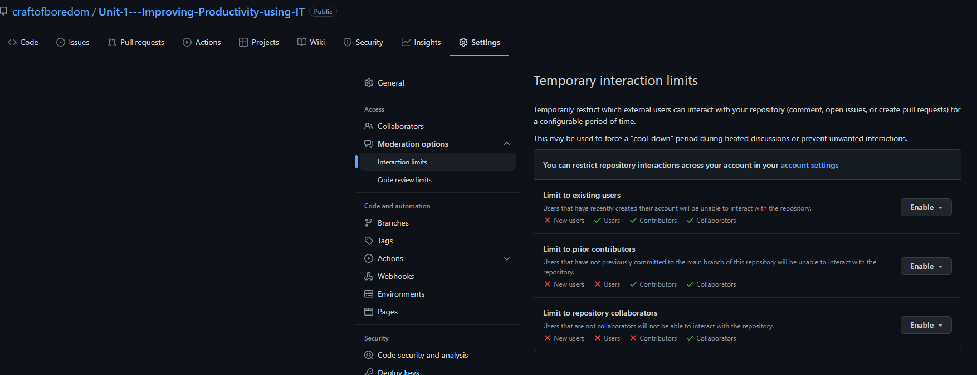



Users can control the access of other users, contributors and collaborators.

## Facebook

Facebook is a successful social media platform that used by billions of people. Since it allows the sharing of personal information online, Facebook has a robust Privacy and Settings features. Users can choose who can view their profile and specific posts, who can comment on their posts, who can send them messages, etc.

